Array

Summer School: GeoTraining

Environmental and Remote Sensing Data Analysis via Geospatial Technologies in Research and Teaching

A training programme for the academic qualification of junior researchers from Africa, Latin America, Middle East, South East Asia and South Asia for scholarship holders in the DAAD In-Country / In-Region Programme

Summer school application
Get more information about the summer school programme and apply for the GeoTraining in Germany.
 Photo taken by Lilli Güssow
Training resource system
The training resource system serves as a open educational resource and provides assignments, tasks, and materials.
generated by Artificial Intelligence


Funded by .
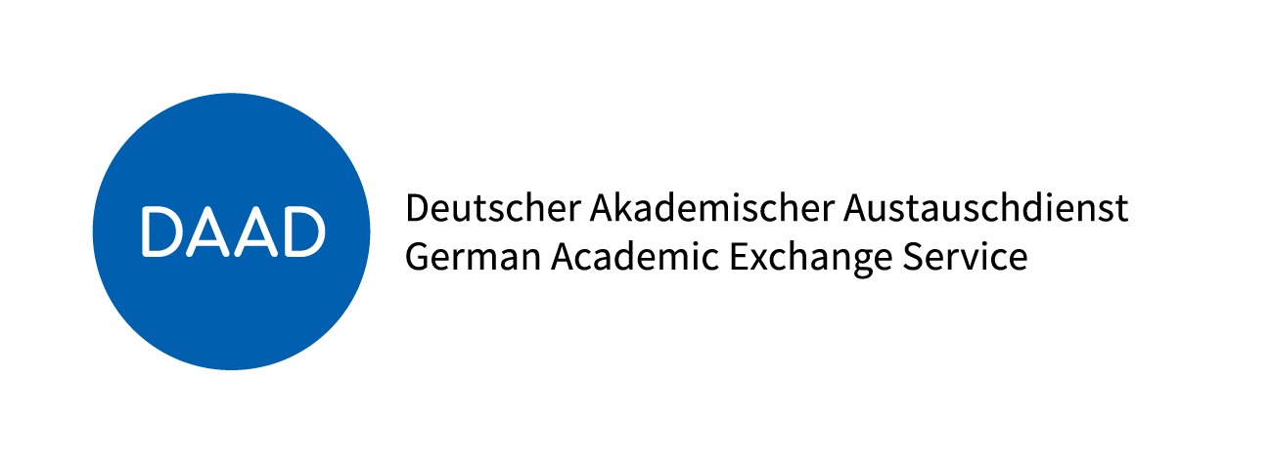DAAD Logo
BMZ Logo
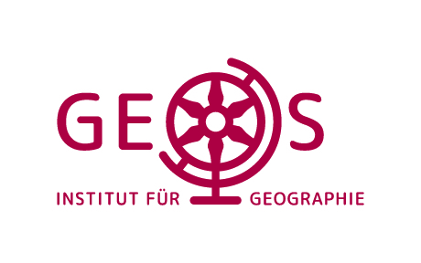
Supported by
Impressum und Datenschutz

