Cultural Activities
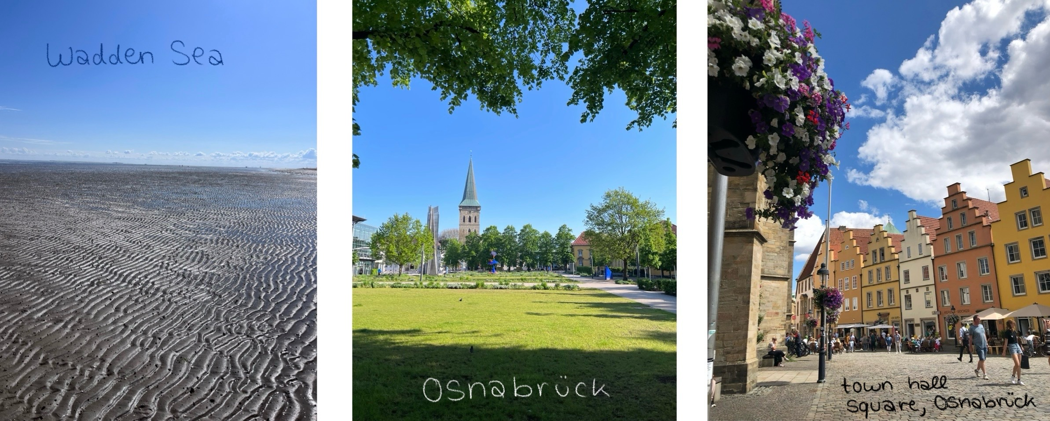photos taken by Lilli Güssow

Content
As part of the advanced training programme, the SPDL-scholarship holders take part in full-day excursions. Here they gain insights in the vocational fields of action of geospatial technologies, national park management, biodiversity, ecology, education, and agricultural and forestry sciences in order to illustrate the practical relevance of these thematic fields and to establish contacts with representatives of vocational practice. Moreover, this allows the different natural and cultural environments of Germany to be experienced in a participant-activating manner.

Specific visits
The excursion programme for 2026 is currently still being finalised. To give you an idea of what to expect, the 2025 programme included the following activities:
- 11.09.2025: Trip to Bonn, Meeting with participants from other Summer Schools and visit of the University of Bonn and the conference “Tropentag” (Agricultural and environmental sciences of the tropics and subtropics)
- 12.09.2025: Visiting DAAD-Head Quarter in Bonn and meeting with participants from other Summer Schools
- 14.09.2025: Trip to the North Sea and watt hike in Wremen with a watt guide, afterwards: visit of the city of Bremen
- 21.09.2025: Excursion to the Piesberg, close to Osnabrück (Geopark TERRA.vita)
- Individual cultural experience: Exploring Germany, individual 1-day or 2-day city tour to a destination of choice → e.g. Münster, Hamburg, Berlin, Lake Dümmer…

Learning goals/outcomes
The participants…
- experience the practical fields of action of geospatial technologies;
- engage in a subject-specific, content-related dialog with representatives of vocational practice;
- know diverse structures and concepts as well as the legal guidelines of conservation areas, agricultural operations, and forestry operations in Germany;
- know the autochthonous and allochthonous flora and fauna of Germany;
- get to know Germany as a location for science;
- become familiar with the structures in the urban and rural areas of Germany;
- gain insights into German society and culture.

